Weblogic JNDI Datasource

## Configure Datasource

1. In WebLogic console home page, select Data Sources under Services.

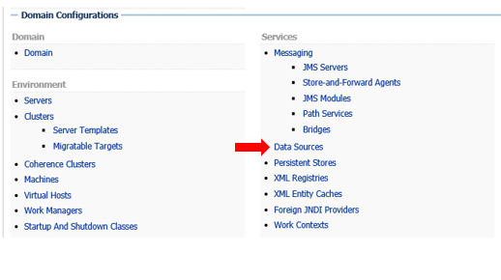

1. Select New > Generic Data Source

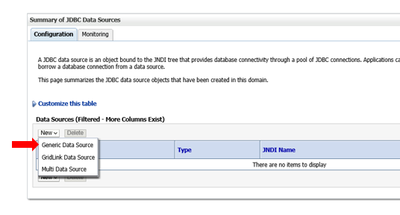

1. Name your Data Source, give it a unique JNDI name, and select the database vendor

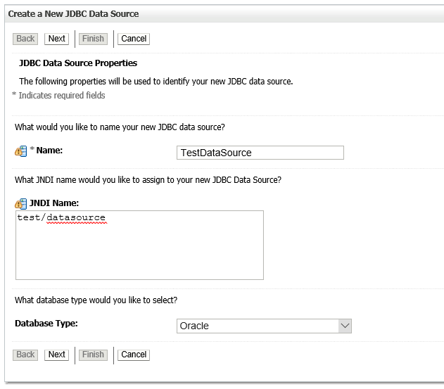

1. Select the Thin Driver

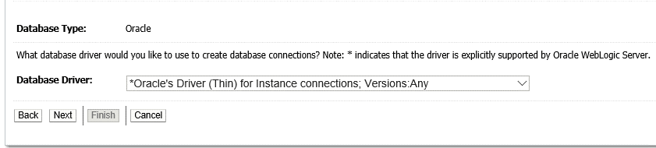

1. Configure Database Properties

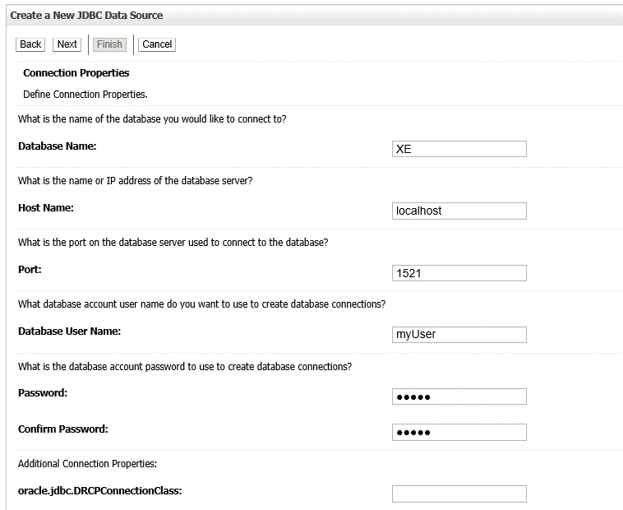

1. Select the server instance where the Data Source will be deployed.

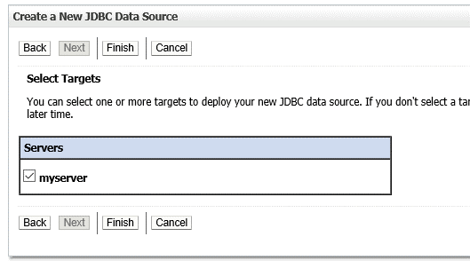

## Access the Datasource in an Application

1. Use javax.naming.Context object to look up the DataSource based on JNDI name
2. IMPORT weblogic external jar found in wls1230/wlsever/server/lib/weblogic.jar
3. JDBC Example:

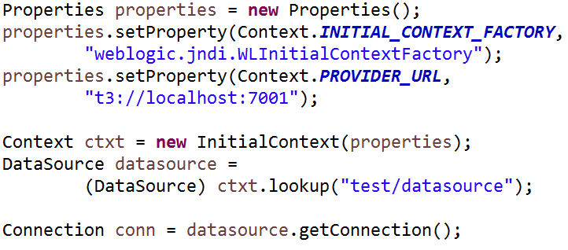

* 1. Alternatively, you can initialize the Context with a properties file instead of setting the Properties programmatically.

**java.naming.factory.initial=weblogic.jndi.WLInitialContextFactory**

**java.naming.provider.url=t3://localhost:7001**

1. Contextual Sessions Example:

<beans ...>

...

<jee:jndi-lookup id="dataSource" jndi-name="test/ds">

<jee:environment>

java.naming.factory.initial=weblogic.jndi.WLInitialContextFactory

java.naming.provider.url=t3://localhost:7001

</jee:environment>

</jee:jndi-lookup>

<bean id="transactionManager"

class="org.springframework.transaction.jta.JtaTransactionManager">

<property name="allowCustomIsolationLevels">

<value>true</value>

</property>

</bean>

<!-- SessionFactory bean --> ...

<!-- DAO bean --> ...

</beans>

1. Plain Hibernate Example:

<hibernate-configuration>

<session-factory>

<property name="hibernate.connection.driver_class">

oracle.jdbc.OracleDriver</property>

<property name="jndi.url">t3://localhost:7001</property>

<property name="jndi.class">

weblogic.jndi.WLInitialContextFactory</property>

<property name="connection.datasource">test/datasource</property>

...

</session-factory>

</hibernate-configuration>

1. You MUST include the wlfullclient.jar dependency in the build if you’re not using a Web App.

Tomcat JNDI Datasource

## Tomcat JNDI DataSource Configuration

For configuring Tomcat container to initialize DataSource, we need to make some changes in tomcat server.xml and context.xml files.

1. Add the resource to server.xml in the GlobalNamingResources element.

<Resource name="jdbc/myoracle" auth="Container"

type="javax.sql.DataSource" driverClassName="oracle.jdbc.OracleDriver"

url="jdbc:oracle:thin:@localhost:1521:xe"

username="scott" password="tiger" maxActive="20" maxIdle="10"

maxWait="-1"/>

1. Link resource in context.xml

<ResourceLink name=" jdbc/myoracle "

global=" jdbc/myoracle "

auth="Container"

type="javax.sql.DataSource" />

1. Access the datasource in the same fashion as described in Weblogic JNDI Datasource section.